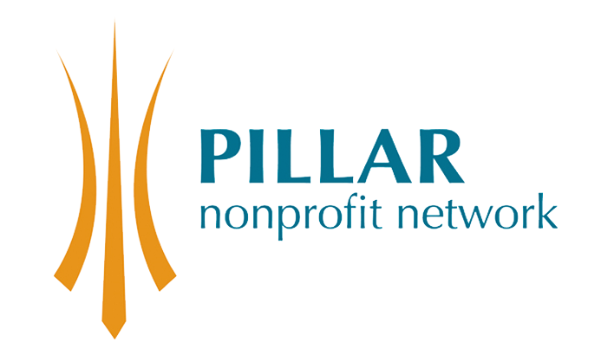

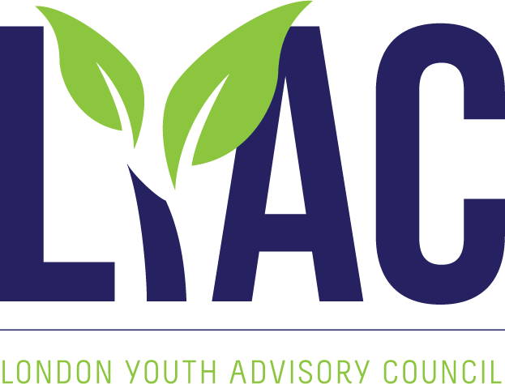

Canada Life Young Leaders Application

Thank you for your interest in the Canada Life Young Leaders Program. This program will fulfill your passions, expand your knowledge and so much more! This program places young leaders on nonprofit Boards of Directors and committees as non-voting members. To participate in this program you must be able to attend training workshops and board meetings over a seven-month period from September to March.

Please complete the following application and send your resume and application to Dharshi Lacey at dlacey@pillarnonprofit.ca by September 18, 2019. The information you provide, along with your resume, will help us learn about your strengths and enhance your learning experience during your participation.

General Information:

What year were you born?
First Name
Last Name
Address
Email contact
Telephone contact

What is your occupation or focus of study (if you are a student)?

Why do you want to participate in the Young Leaders Program?

What do you hope to learn as a result of your participation in the Young Leaders program?

What type of nonprofit organization would you be interested in volunteering with?
(i.e.: health, recreation, employment, etc. Please feel free to review the membership list of Pillar Nonprofit Network on its website https://pillarnonprofit.ca/about/member-organizations to help you with this response)

How did you hear about the Young Leaders program?

Pillar website
Youth Advisory Council Website
United Way
Western Career Central
Fanshawe College website
Family, friend or colleague
Other (please specify)

